NC4
First character of name cannot have space-
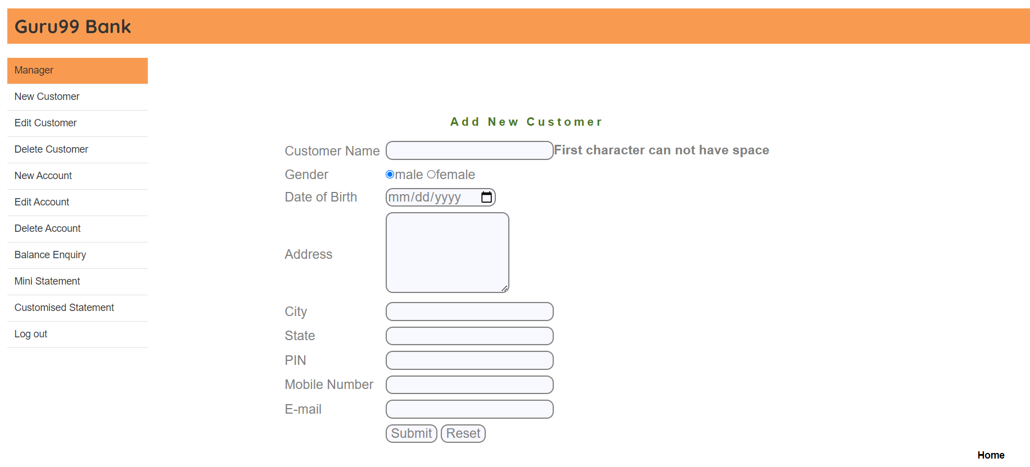

NC5-Address cannot be empty-
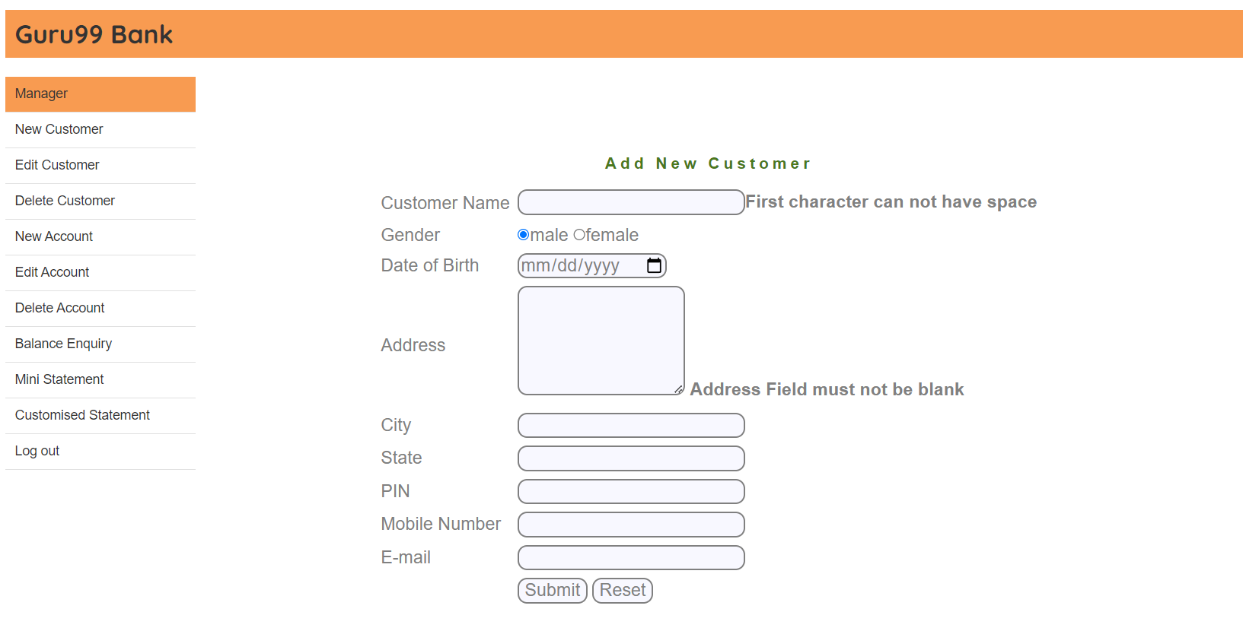

NC13-State cannot have first blank space
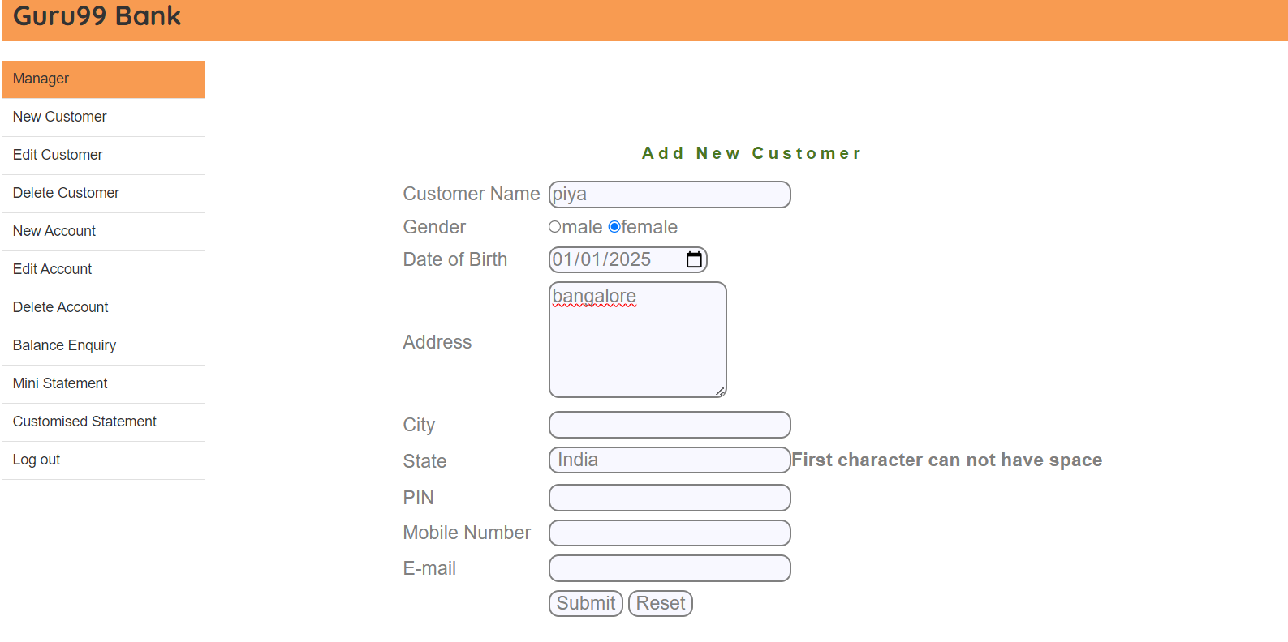

NC18-PIN cannot have first character as blank space
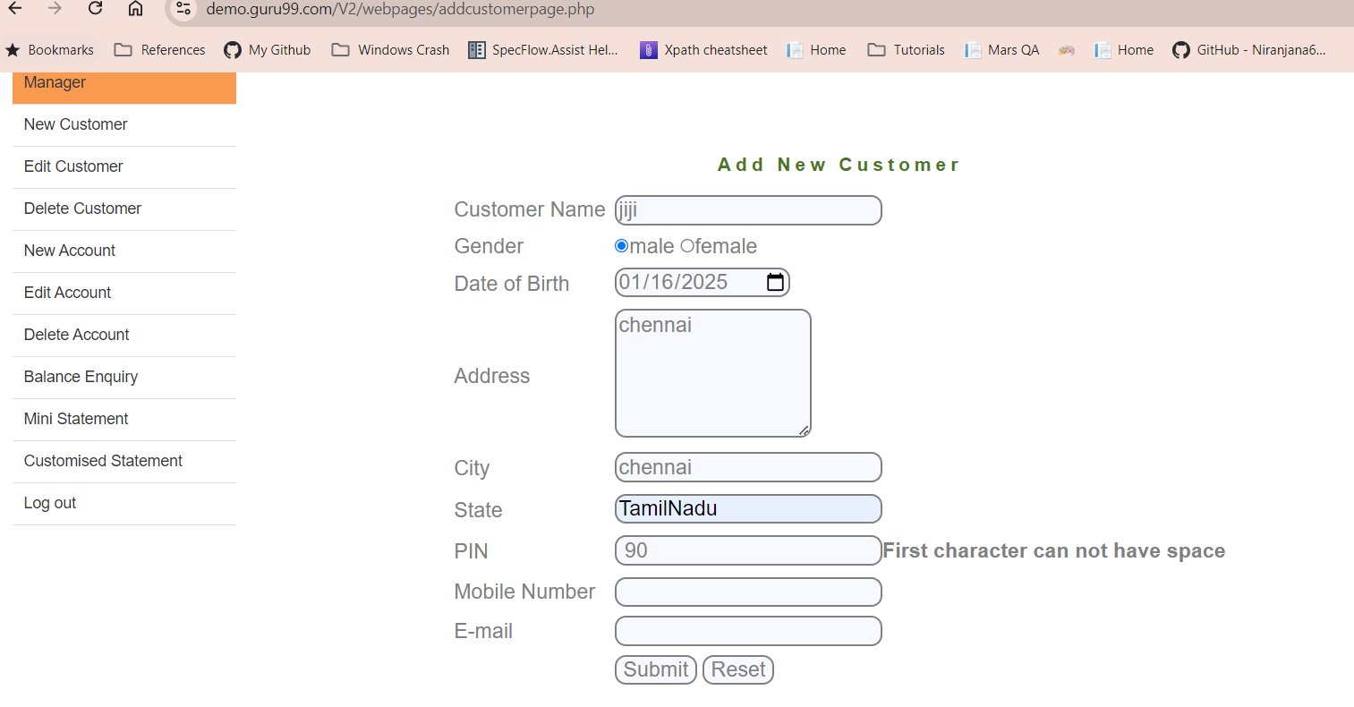

NC20- Telephone cannot have first character as blank space
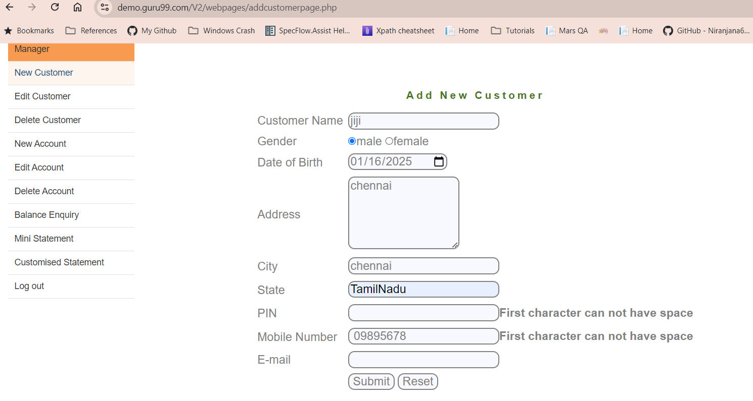
NC25- Email cannot have space- An error message "Email-ID is not valid" must be shown
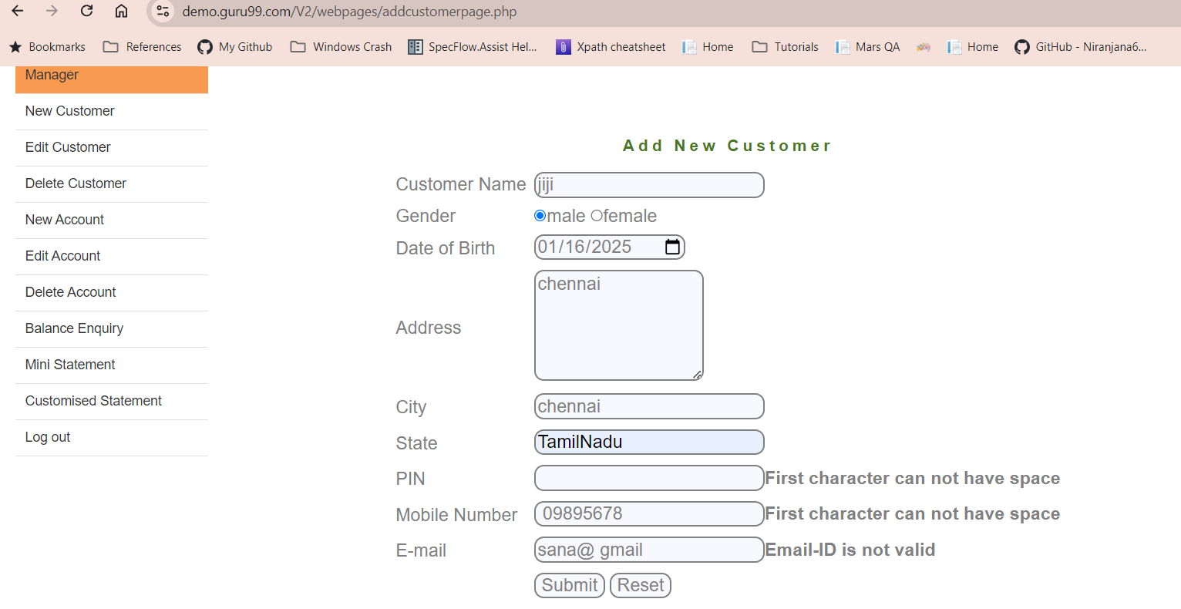

NC-27-Customer registered successfully message displayed
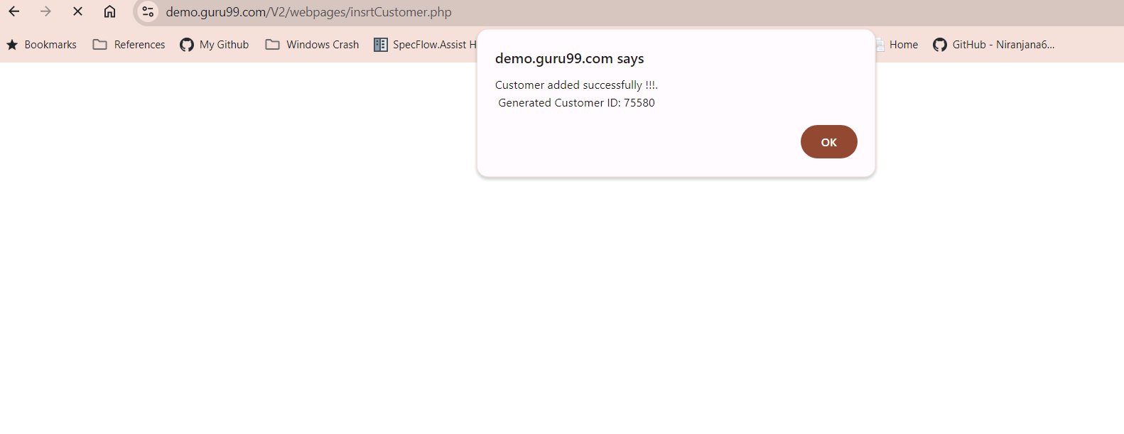
NA3- Unable to Add a new Account with Initial deposit less than 500
No error message displayed-initial deposit must be above 500

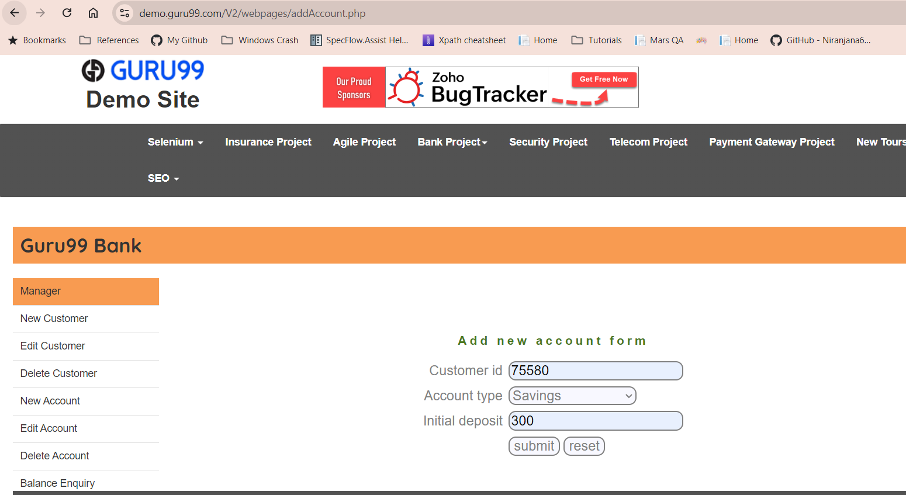

NA4- Verifying the customer ID field
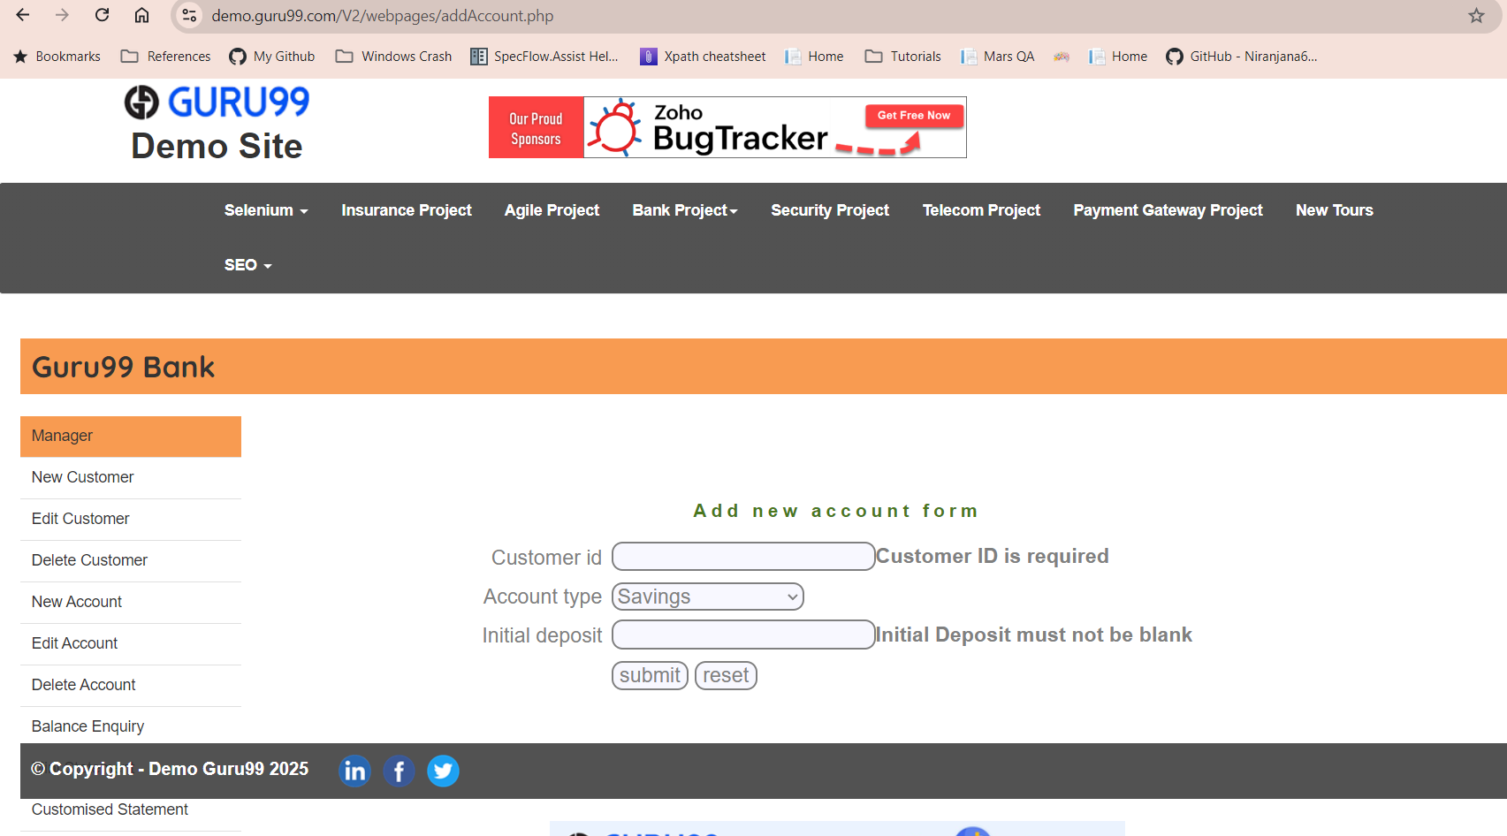
NA5- Verify nonnumeric field in customer ID
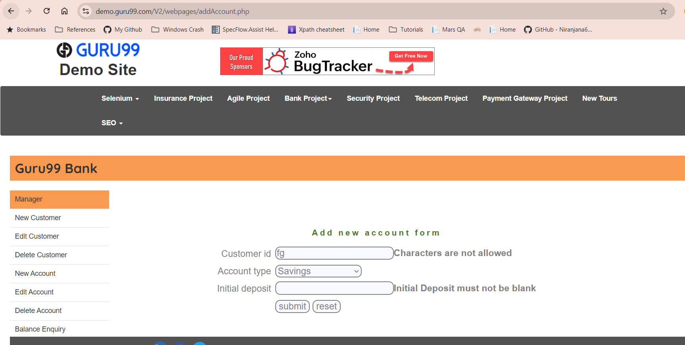

NA6- Verify customer ID with special character
